**8) Write the SQL that will be needed to answer the three most important questions using your data warehouse. This requires writing 3 SQL statements. (10 points)**

1. How are the various resorts performing financially?

I create a new fact table since my current fact tables had facts for room_bookings and facts for event_bookings. For an overall picture, I want just a bookings table with both sets of facts:

|  |
| --- |
| create table if not exists booking as (select evbk_time_id as time_id, evbk_evcst_id as cst_id, evbk_rst_id as rst_id, evbk_amount as amount from event_booking);  insert into booking (select rmbk_time_id as time_id, rmbk_rmcst_id as cst_id, rmbk_rst_id as rst_id, rmbk_amount as amount from room_booking); |

The most basic query, Resort Revenue with rollup:

|  |
| --- |
| select   r.RST_NAME as Name,   sum(amount ) as revenue  from booking b  join resort r on b.RST_ID = r.RST_ID  group by r.RST_NAME  with rollup; |

**Table 1: Revenue by Resort**

|  |  |
| --- | --- |
| Resort 1 | 1600.00 |
| Resort 2 | 1200.00 |
| Resort 3 | 2600.00 |
| Resort 4 | 1400.00 |
| Resort 5 | 2600.00 |
|  | 9400.00 |

Revenue by state:

|  |
| --- |
| select r.RST_STATE as Name, sum(amount) as revenue  from booking b  join resort r on b.RST_ID = r.RST_ID  group by r.RST_STATE  with rollup; |

**Table 2: Revenue by State**

|  |  |
| --- | --- |
| British Columbia | 1300.00 |
| California | 1400.00 |
| Illinois | 1300.00 |
| New York | 700.00 |

Revenue by Resort by Day of Week with rollup:

|  |
| --- |
| select r.RST_NAME as Name, t.time_dow as Dow, sum(amount) as revenue  from booking b  join resort r on b.RST_ID = r.RST_ID  join time t on b.TIME_ID = t.TIME_ID  group by name asc, dow asc  with rollup; |

**Table 3: Resort by DOW by Revenue**

|  |  |  |
| --- | --- | --- |
| Resort 1 | 2 | 200.00 |
| Resort 1 | 3 | 800.00 |
| Resort 1 | 4 | 600.00 |
| Resort 1 |  | 1600.00 |
| Resort 2 | 1 | 800.00 |
| Resort 2 | 7 | 400.00 |
| Resort 2 |  | 1200.00 |
| Resort 3 | 5 | 1200.00 |
| Resort 3 | 6 | 1400.00 |
| Resort 3 |  | 2600.00 |
| Resort 4 | 1 | 200.00 |
| Resort 4 | 3 | 600.00 |
| Resort 4 | 6 | 600.00 |
| Resort 4 |  | 1400.00 |
| Resort 5 | 1 | 400.00 |
| Resort 5 | 2 | 400.00 |
| Resort 5 | 5 | 400.00 |
| Resort 5 | 6 | 1400.00 |
| Resort 5 |  | 2600.00 |
|  |  | 9400.00 |

1. How are overnight guests utilizing the facilities?

Which Counties are Customers coming from?

|  |
| --- |
| select rc.RMCST_CNTRY, count(*)  from room_booking rb  join room_customer rc on rb.RMBK_RMCST_ID = rc.RMCST_ID  group by rc.RMCST_CNTRY; |

**Table 4: Country by Customer Count**

|  |  |
| --- | --- |
| Canada | 4 |
| United States | 16 |

What State are customers coming for each Resort State?

|  |
| --- |
| select r.RST_STATE, rc.RMCST_STATE, count(*)  from room_booking rb  join room_customer rc on rb.RMBK_RMCST_ID = rc.RMCST_ID  join resort r on rb.RMBK_RST_ID = r.RST_ID  group by r.RST_STATE, rc.RMCST_STATE  with rollup; |

**Table 5: Resort State by Customer State by Count**

|  |  |  |
| --- | --- | --- |
| British Columbia | California | 1 |
| British Columbia | Ontario | 1 |
| British Columbia | Quebec | 2 |
| British Columbia | Texas | 1 |
| British Columbia |  | 5 |
| California | California | 5 |
| California | New York | 1 |
| California | Texas | 2 |
| California |  | 8 |
| Illinois | California | 2 |
| Illinois | Ontario | 1 |
| Illinois | Texas | 1 |
| Illinois |  | 4 |
| New York | California | 2 |
| New York | Texas | 1 |
| New York |  | 3 |
|  |  | 20 |

How much spending does each State account for?

|  |
| --- |
| select rc.RMCST_STATE, sum(rb.RMBK_AMOUNT)  from room_booking rb  join room_customer rc on rb.RMBK_RMCST_ID = rc.RMCST_ID  group by rc.RMCST_STATE  with rollup; |

**Table 6: State by Sum Spent**

|  |  |
| --- | --- |
| California | 2300.00 |
| New York | 100.00 |
| Ontario | 800.00 |
| Quebec | 400.00 |
| Texas | 1100.00 |
|  | 4700.00 |

1. How are Event Groups using the facilities?

What States do Event Groups come from?

|  |
| --- |
| select ec.EVCST_STATE, count(*)  from event_booking eb  join event_customer ec on eb.EVBK_EVCST_ID = ec.EVCST_ID  group by ec.EVCST_STATE  with rollup; |

**Table 7: Event Groups by State**

|  |  |
| --- | --- |
| California | 5 |
| New York | 1 |
| Ontario | 2 |
| Quebec | 2 |
| Texas | 10 |
|  | 20 |

How many Events does each State account for by Resort?

|  |
| --- |
| select ec.EVCST_CITY, r.RST_NAME, count(*)  from event_booking eb  join event_customer ec on eb.EVBK_EVCST_ID = ec.EVCST_ID  join time t on eb.EVBK_TIME_ID = t.TIME_ID  join resort r on eb.EVBK_RST_ID = r.RST_ID group by ec.EVCST_CITY, r.RST_NAME  with rollup; |

**Table 8: Group City by Resort by Count**

|  |  |  |
| --- | --- | --- |
| Austin | Resort 2 | 2 |
| Austin | Resort 3 | 1 |
| Austin | Resort 4 | 1 |
| Austin | Resort 5 | 1 |
| Austin |  | 5 |
| Berkeley | Resort 1 | 1 |
| Berkeley | Resort 4 | 1 |
| Berkeley |  | 2 |
| Dallas | Resort 1 | 3 |
| Dallas | Resort 3 | 1 |
| Dallas | Resort 5 | 1 |
| Dallas |  | 5 |
| Montreal | Resort 5 | 2 |
| Montreal |  | 2 |
| New York City | Resort 2 | 1 |
| New York City |  | 1 |
| San Francisco | Resort 1 | 1 |
| San Francisco | Resort 3 | 1 |
| San Francisco | Resort 4 | 1 |
| San Francisco |  | 3 |
| Toronto | Resort 3 | 1 |
| Toronto | Resort 5 | 1 |
| Toronto |  | 2 |
|  |  | 20 |

**9) Create a visualization for your first management question.**

1. How are the various resorts performing financially?

This graph looks at each Resort and shows Booking Revenue on a Day of Week basis. From this visualization management can conclude that Resorts 1 and 2 are booked primarily at the beginning of the week, Resort 3 at the end of the week and Resorts 4 and 5 throughout the week.

**11) Create a visualization for your second management question. (Note: it must be different than the first and ideally use different fact or dimension tables).**

1. How are overnight guests utilizing the facilities?

This graphic, produced in Excel, shows where customers are originating from for the various Resorts. The States in which Resort are located are indicated by the locations of the pie charts, and the pie charts themselves show how many customers are originating from each state as described in the legend.

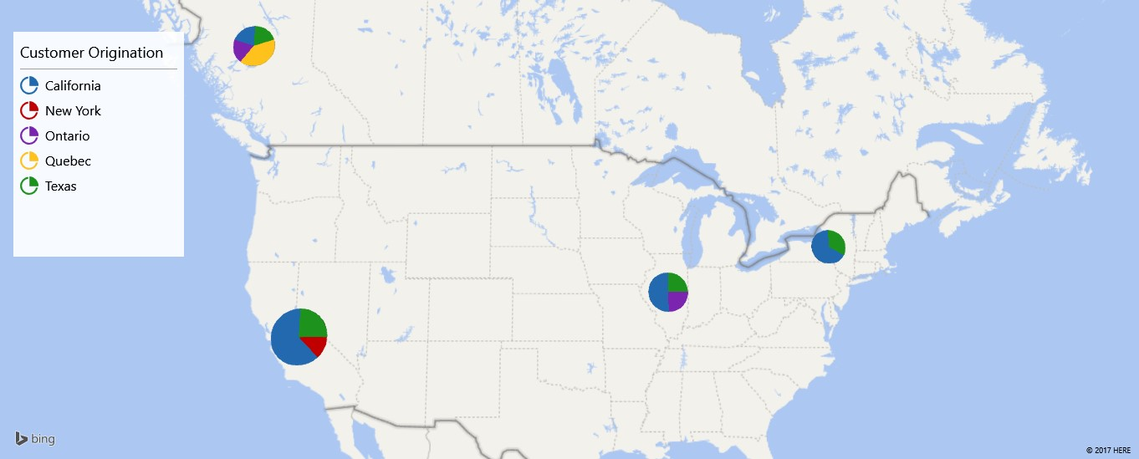

**12) Create a third visualization, it must be different than the first two and should use different fact or dimension tables.**

This simple graphic just shows the number of Event Bookings per Resort. The time period is not specified and assumed to be the total for the entire dataset.